2.
if [ $# -ne 1 ]
then
echo "you must enter in correct format"
echo "filename.extension number"
echo "eg: $0 1234"
exit 1
fi

n=$1
sd=0
rev=0

while [ $n -gt 0 ]
do
sd=`expr $n % 10`
rev=`expr $rev \* 10 + $sd`
n=`expr $n / 10`
done
echo "reverse $rev"
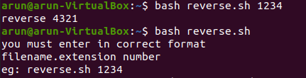

3.
sed 's/ //g' new.txt

4.

